Monday 17 September 2007
Day fifteen

Last day of the harvest

It was under a dark, heavy sky that the last grapes were picked on the Côte de Nuits, as the final curtain fell on the Clos du Prieuré blanc and a small team of 17 vendangeurs. But the 2007 harvest came to a close with a smile as the grapes gathered weighed in at 12.5°, confirming once again that our decision to postpone harvesting the whites this year has truly born fruit.
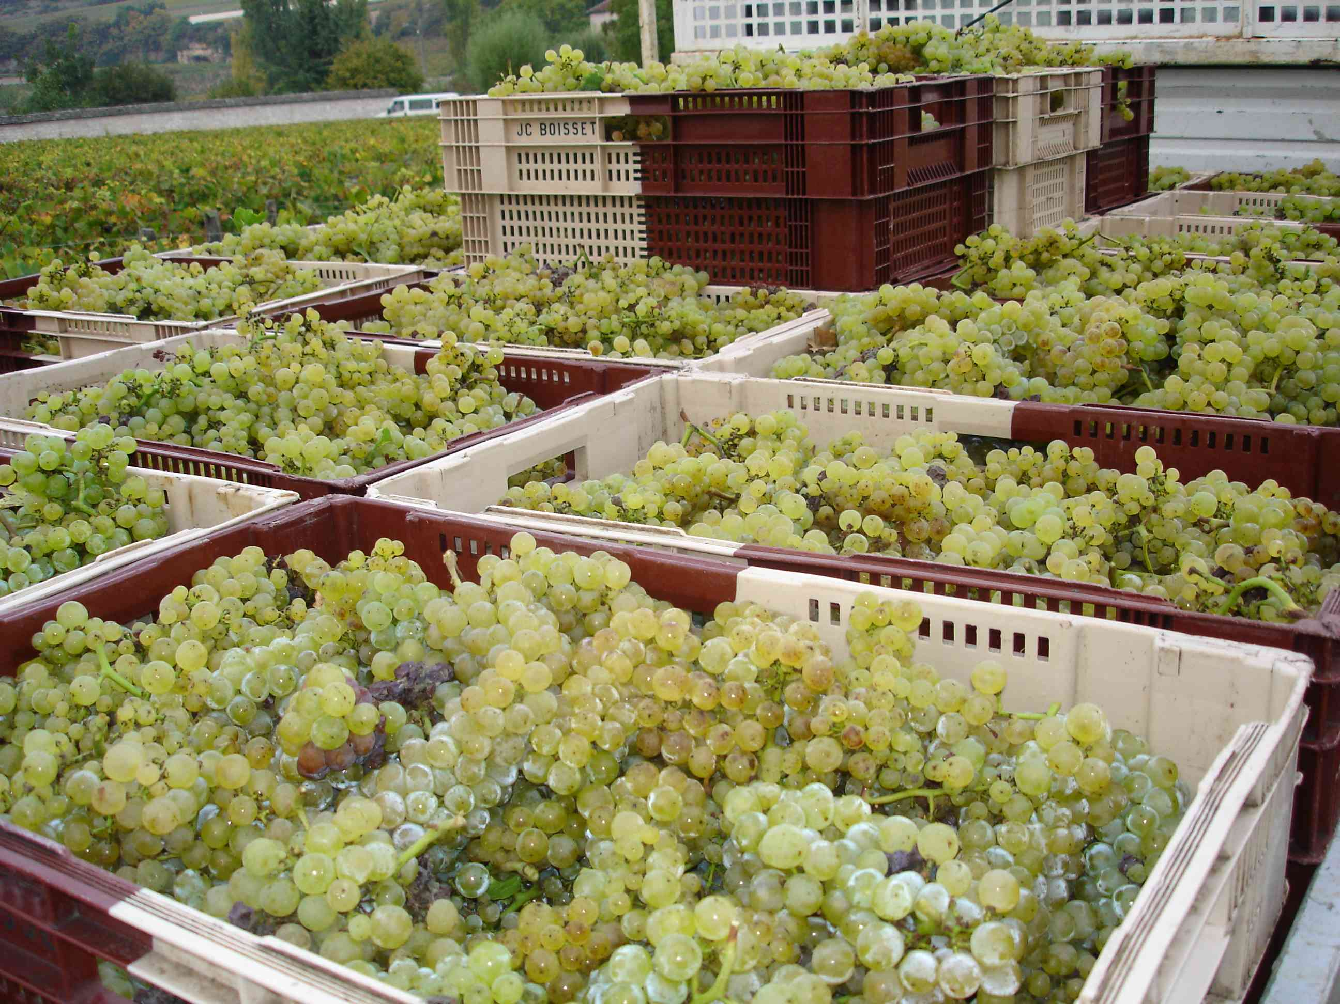

The harvest was the equivalent of two presses’ worth – the last of this year – and then calm returned to the winery. The sounds of chatting sorters bent over their work has given way to that characteristic smell of fermenting grape juice that fills the streets of the local wine-producing villages as they regain some of their characteristic sleepiness.

The 31 vats are full and are the object of daily checks and treatments: pigeages with the feet, pumping over and density analysis.

Le Clos Blanc is murmuring in its barrels after a week of cold stabulation at 12°. The last cuvée has just been put into barrels and has joined the other whites to begin maturing in the quiet and darkness. The almost religious peace of the cellar is barely disturbed by the arrival of seven pièces of our Fête de Famille. The Domaine’s Crémant de Bourgogne, whose grapes were the first to be harvested on August 30, is giving off a delicate perfume of rose and aromas of red berries; the indication of a future wine of great class that will not be revealed for several years to the great delectation of our taste buds.

But behind the wines, there are men and women and we are obliged to give a mention to the Domaine’s head of cultivation and manager of the Côte de Beaune team, Fabrice Bourgogne. With such a name, it was perhaps fate that brought him to our very best plots, this man of the land who knows his vines and how to draw the very essence out of them.

Elsewhere, the cellar is a hive of activity. With a hundred barrels already filled and more wine to come, our cellarman Jean-Luc is working non-stop to prepare the barrels. They must be rinsed with clean water to “refresh” them, aligned in perfect rows – our cellarman is just as meticulous and scrupulous as Pierre – and then stacked on two levels. But this is a very precise task, and the older barrels make up the base, or the fonçure, and the new ones the upper level.
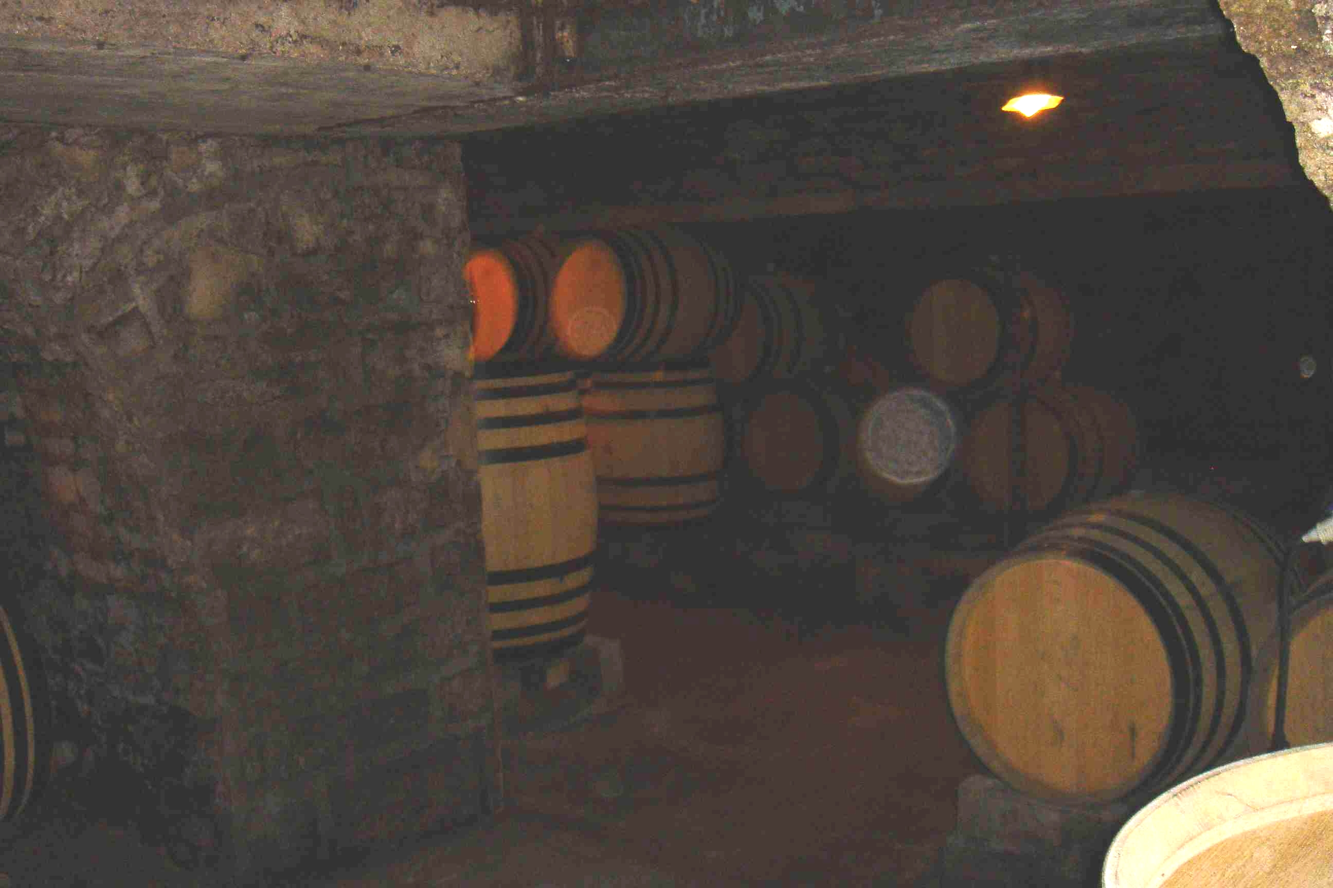

Devatting the reds will begin at the end of the week with the Savigny-lès-Beaune Les Marconnets, which will then be pressed in our celebrated vertical press.

And it is with a touch of regret that we must close this chapter of the harvest, but we will be back soon with the next edition of the Domaine de la Vougeraie letter. Now it’s time to embark upon a new adventure for our wines with the maturation process which will take us until 2009…

