Saturday 15 September 2007
Day thirteen

Life through white and gold-colored glasses...
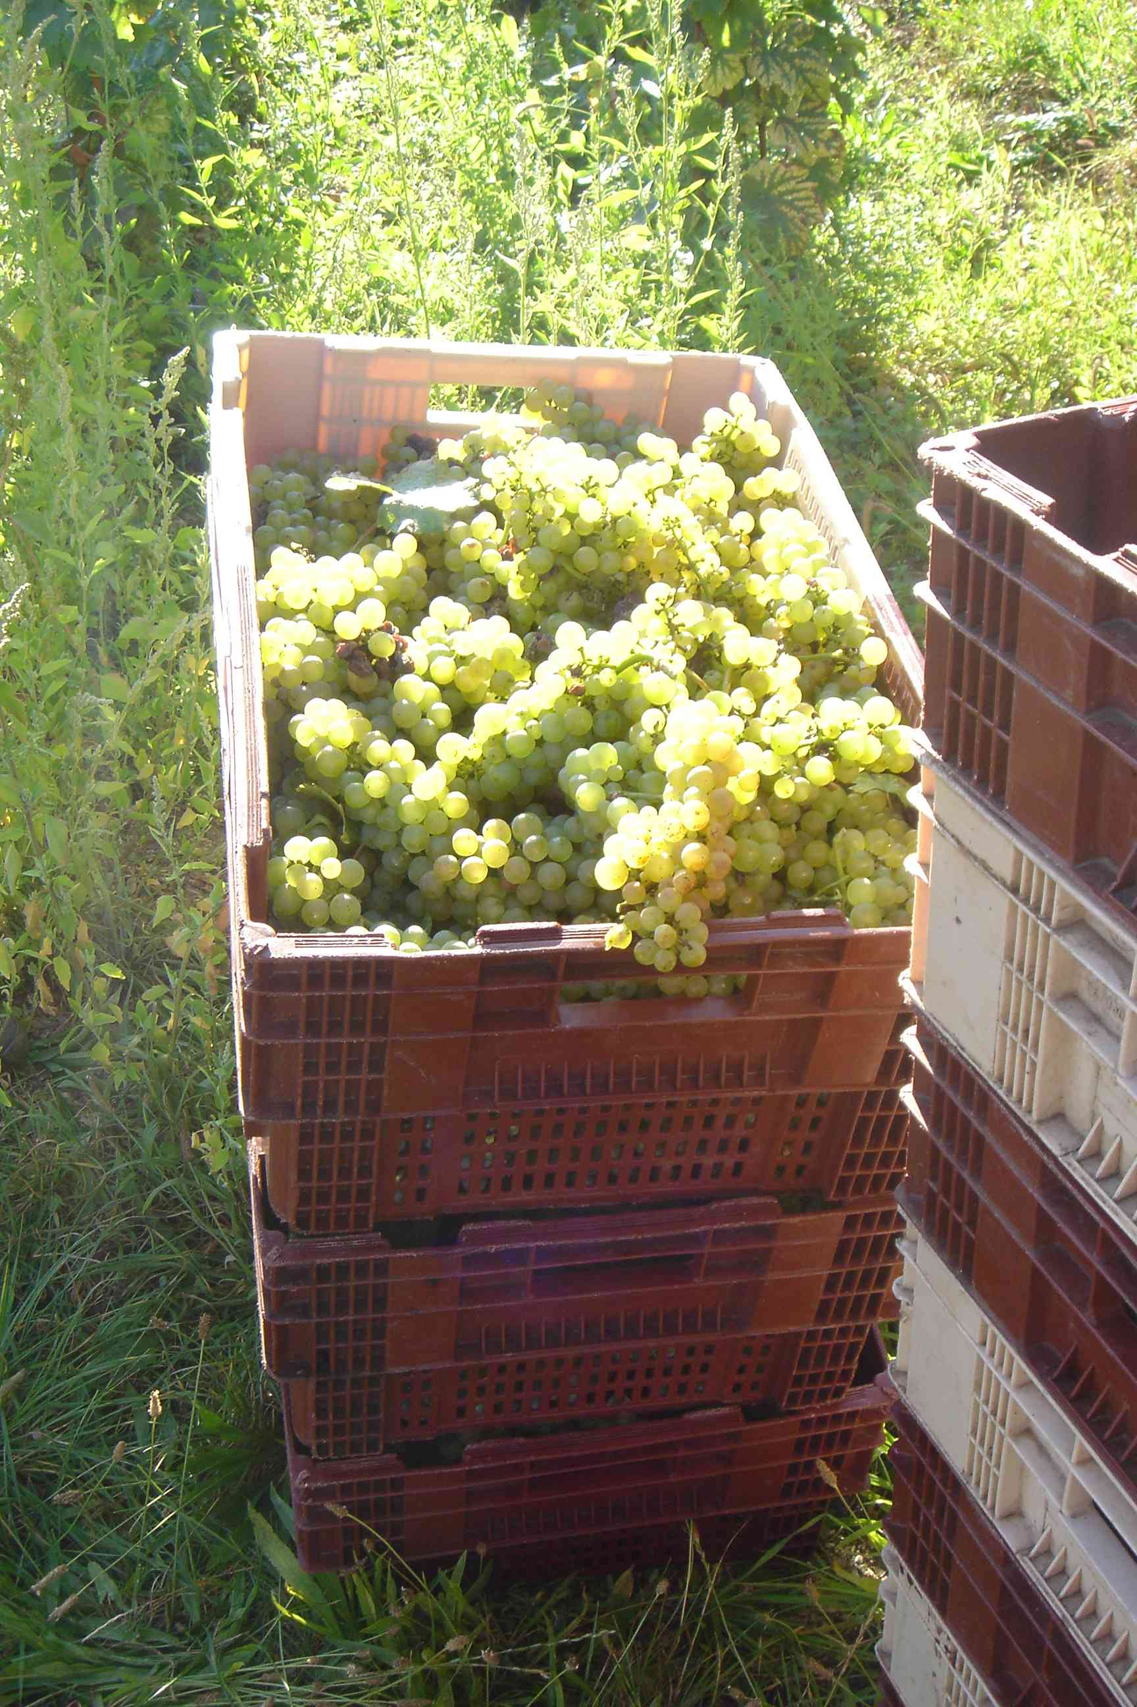

The summer came up trumps on this very busy day when the harvesting team was at full complement for one last time. The temperature was up to 25°C (77°F) with a hot sun beating down, and we couldn’t have wanted for more on this Côte where vendangeurs are now a very rare sight.

Over towards Beaune, a small team set to harvesting the last 70 cases of Côte de Beaune blanc Les Pierres Blanches.

On the Côte de Nuits, it was also the last vendange for the Clos Blanc in the upper part of the triangle where here and there, you can spot traces of chlorosis caused by the combination of chalk and humidity, which makes the leaves turn yellow. But this didn’t stop the vines from producing fine golden grapes with millerandage – something we’ve not seen much of here – that weighed in at 12.8°. This vine has never gone below 12.5°, so it won’t need any chaptalization.

The afternoon was dedicated to the Clos du Prieuré blanc, situated just below, and where a third of the vine was harvested. The grapes showed a fair amount of millerandage here too, and they are even lightly figuées, with a high sugar and low water content due to the effect of the sun and wind combined with botrytis, which we left as this noble rot brings a slight sweetness to the wine. The last two-thirds will be harvested on Monday morning by a reduced team of pickers.

Pierre was delighted with the quality of the whites which showed very good pH levels of 3.2 and good total acidity at 6.5, heralding an exceptional year for our dear Clos Blanc. We congratulated ourselves for having waited to harvest, because these splendid raw materials with their intense color are the stuff of divine wines.
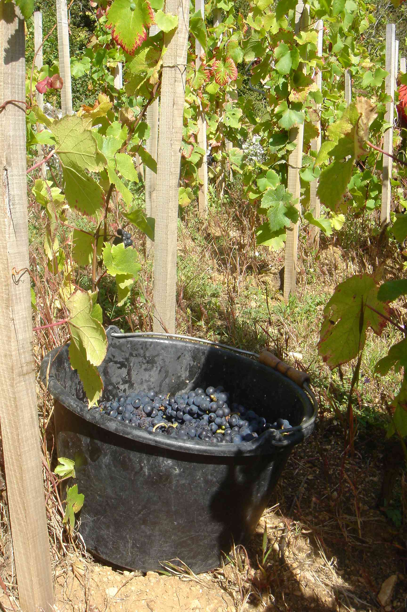

The grapes were lightly sorted and then pressed, while the valiant winery team partially destalked some 200kg of Musigny. This year’s harvest will give us two-and-a-half precious pièces. This year, for the first time, Pierre has decided to keep a tenth of the bunches whole to the great relief of the de-stalkers who are reaching the end of their tether. Their task is to select the best bunches with millerandage and cut off the excess stalk with secateurs. The idea is to keep these many, invaluable tiny grapes perfectly intact – which tend to be lost even with the most dedicated hand-destalking – to give body to the wine. A select few will enjoy the results in a few months’ time.

These most beautiful examples of pinot nor perfection are the star players in our quartet of excellence alongside Les Bonnes Mares, Les Mazoyères and Les Evocelles en Foule, all born from magnificent sloping plots with well-drained soil that didn’t suffer from this summer’s excess humidity.

And the fermentations are going crazy! A third of the vats are now exuding the characteristic aromas accompanied by a discreet spluttering. This means fewer pigeages necessary for such spontaneous matter. In the cellar. Jean-Luc has set the extractors working in advance of an unheard-of volume of whites in barrels, which are at around 10°, but you never know... The crémant has swiftly heated up and has begun to ferment, taking on a rosy hue. Tonight we finished early, in time for the Paulée celebration which Thierry Jeannin has spent the entire day preparing for, and will welcome some 80 people...

