Friday 14 September 2007
Day twelve

Magic in the air...

The lingering summer seems to be stretching its web of influence across the entire Côte, with the mercury tipping 26°C (79°F), and giving a welcome boost to the harvesters’ enthusiasm as well as the fermentations, and smoothing away any signs of fatigue.
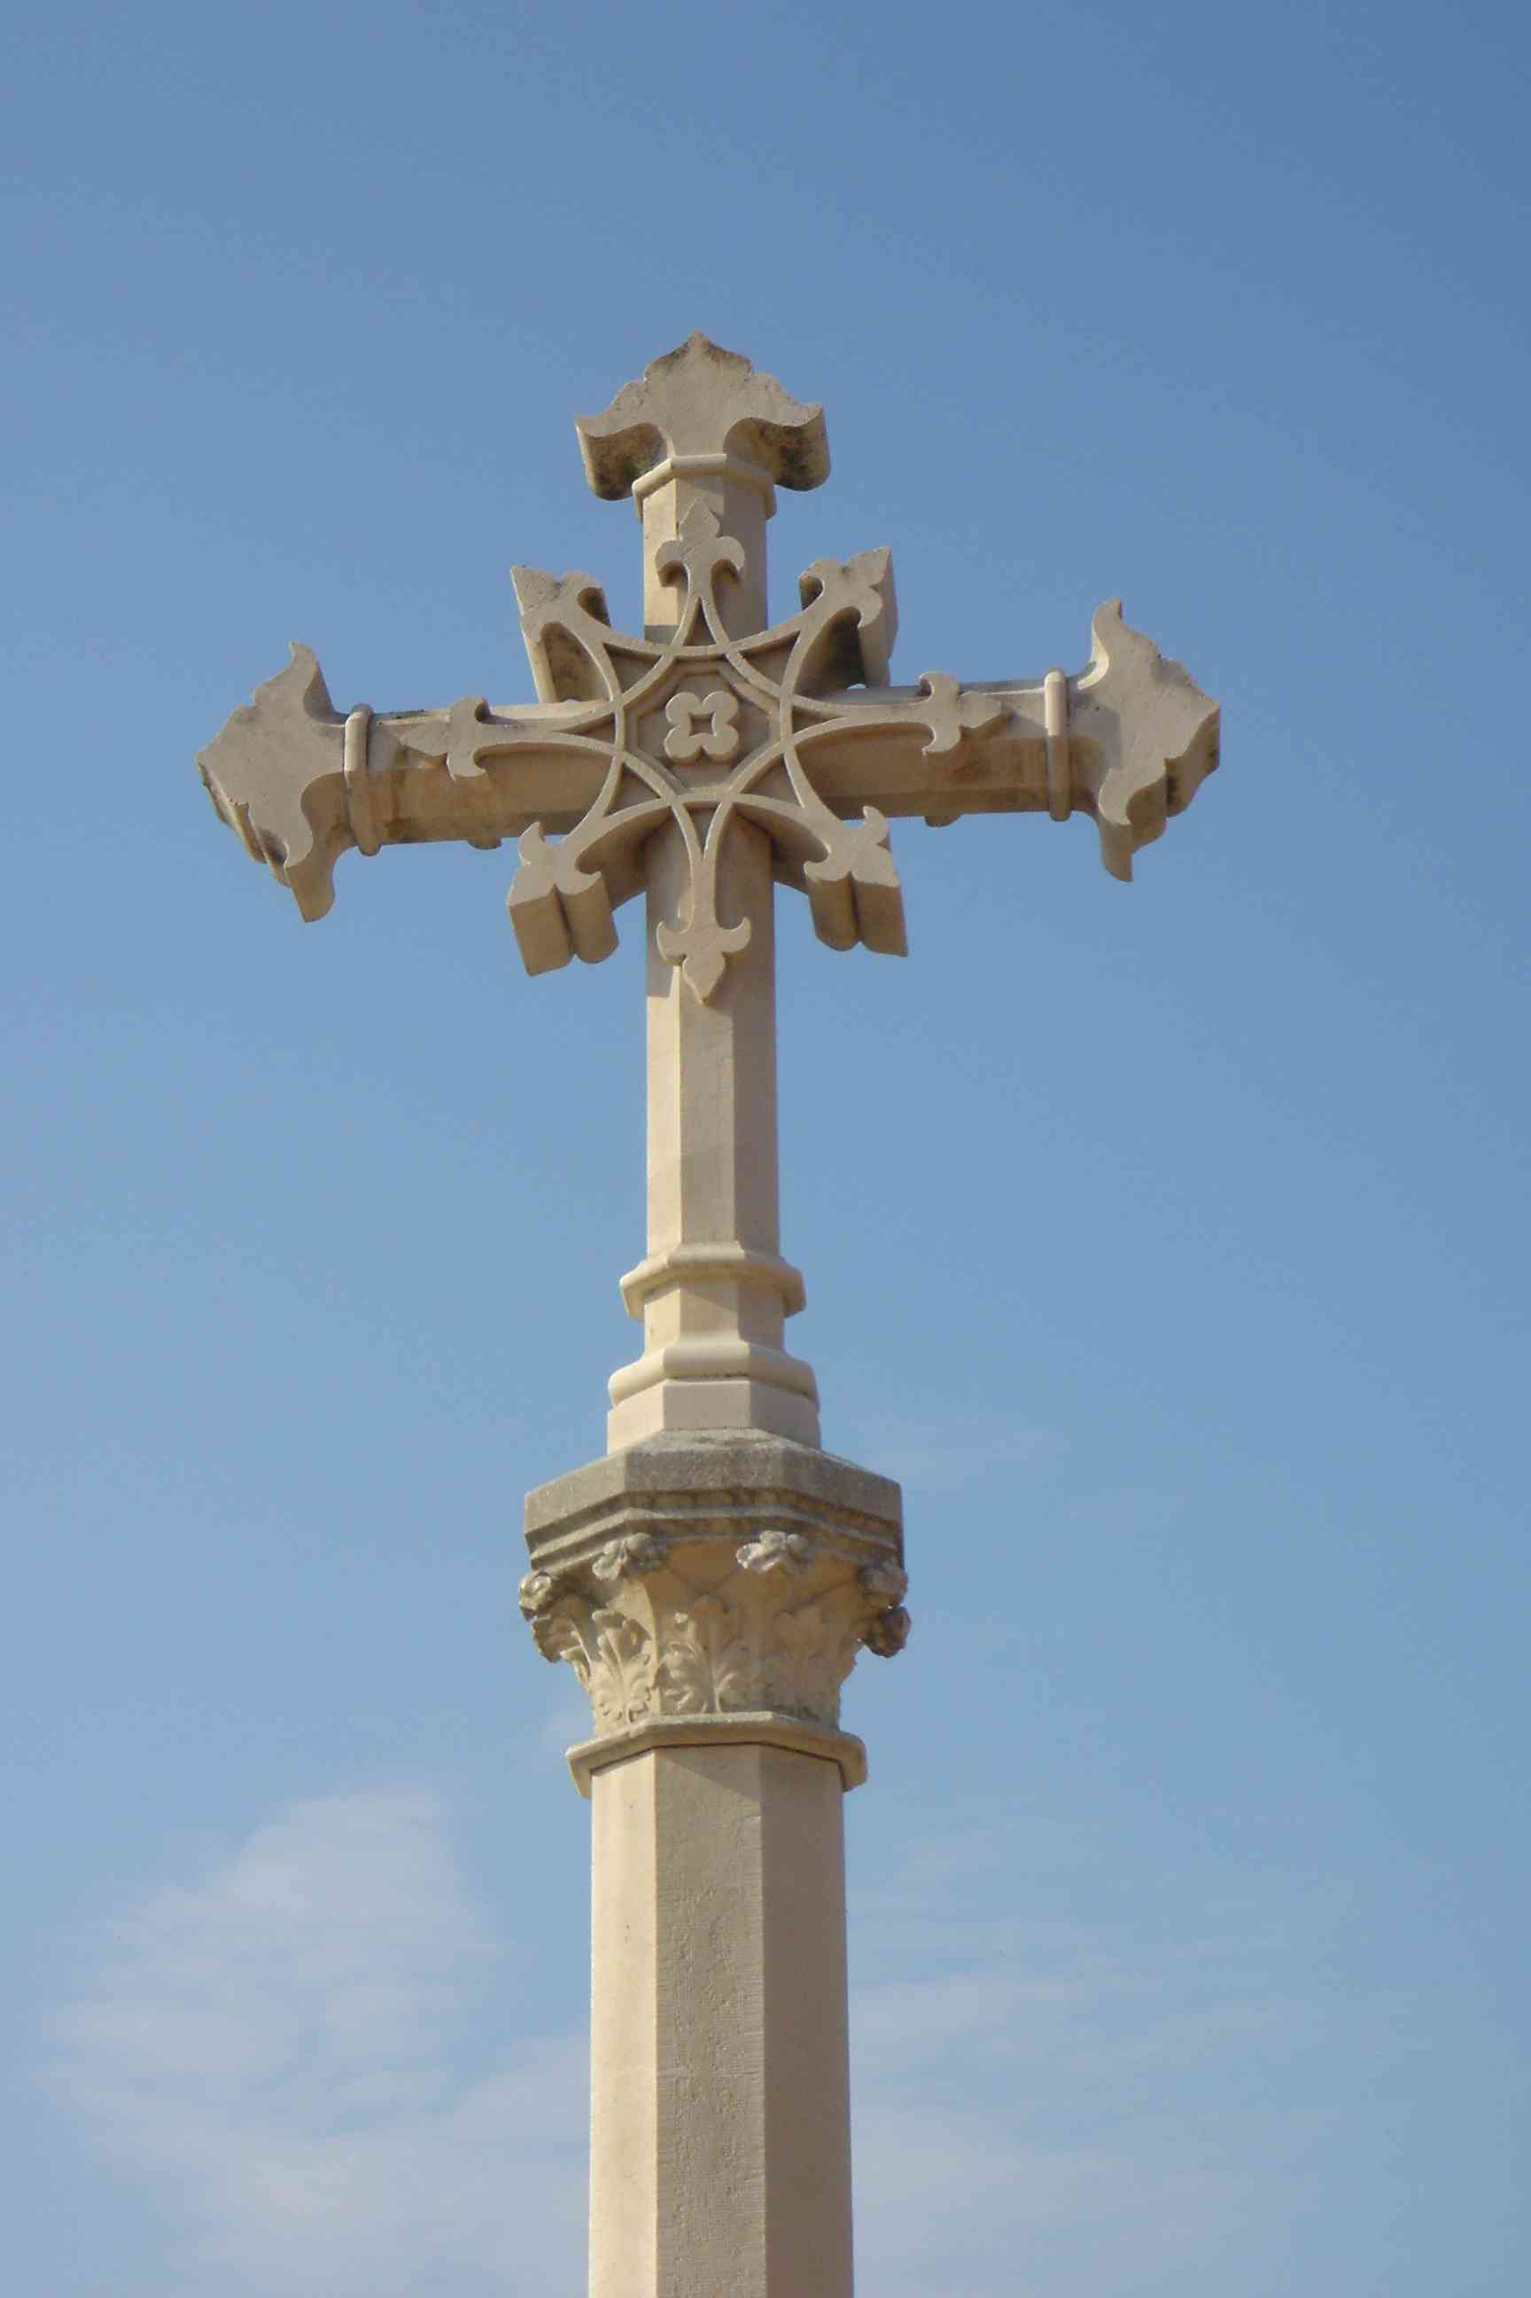
Today was very busy as we approach the end of the harvest, with the working rhythm soon up to speed with renewed vigor. On the Côte de Beaune, the wonderful morning began with the no-less-wonderful plot of Corton-Charlemagne, the grand cru that sits elegantly along the flank of a rounded hill, protected by its saint and nearby cross. Its long, sloping rows, gave sublime and perfectly-golden bunches to be carried away by the haulers with the promise of another great wine. The team then headed to the Montage de Beaune and the Côte de Beaune Les Pierres Blanches where they continued with the whites and finished off the reds. Quite a lot of rot required some drastic sorting, but in the winery, this is now par for the course. During the afternoon, they set off once again to lend a helping hand to some of our associate maisons.
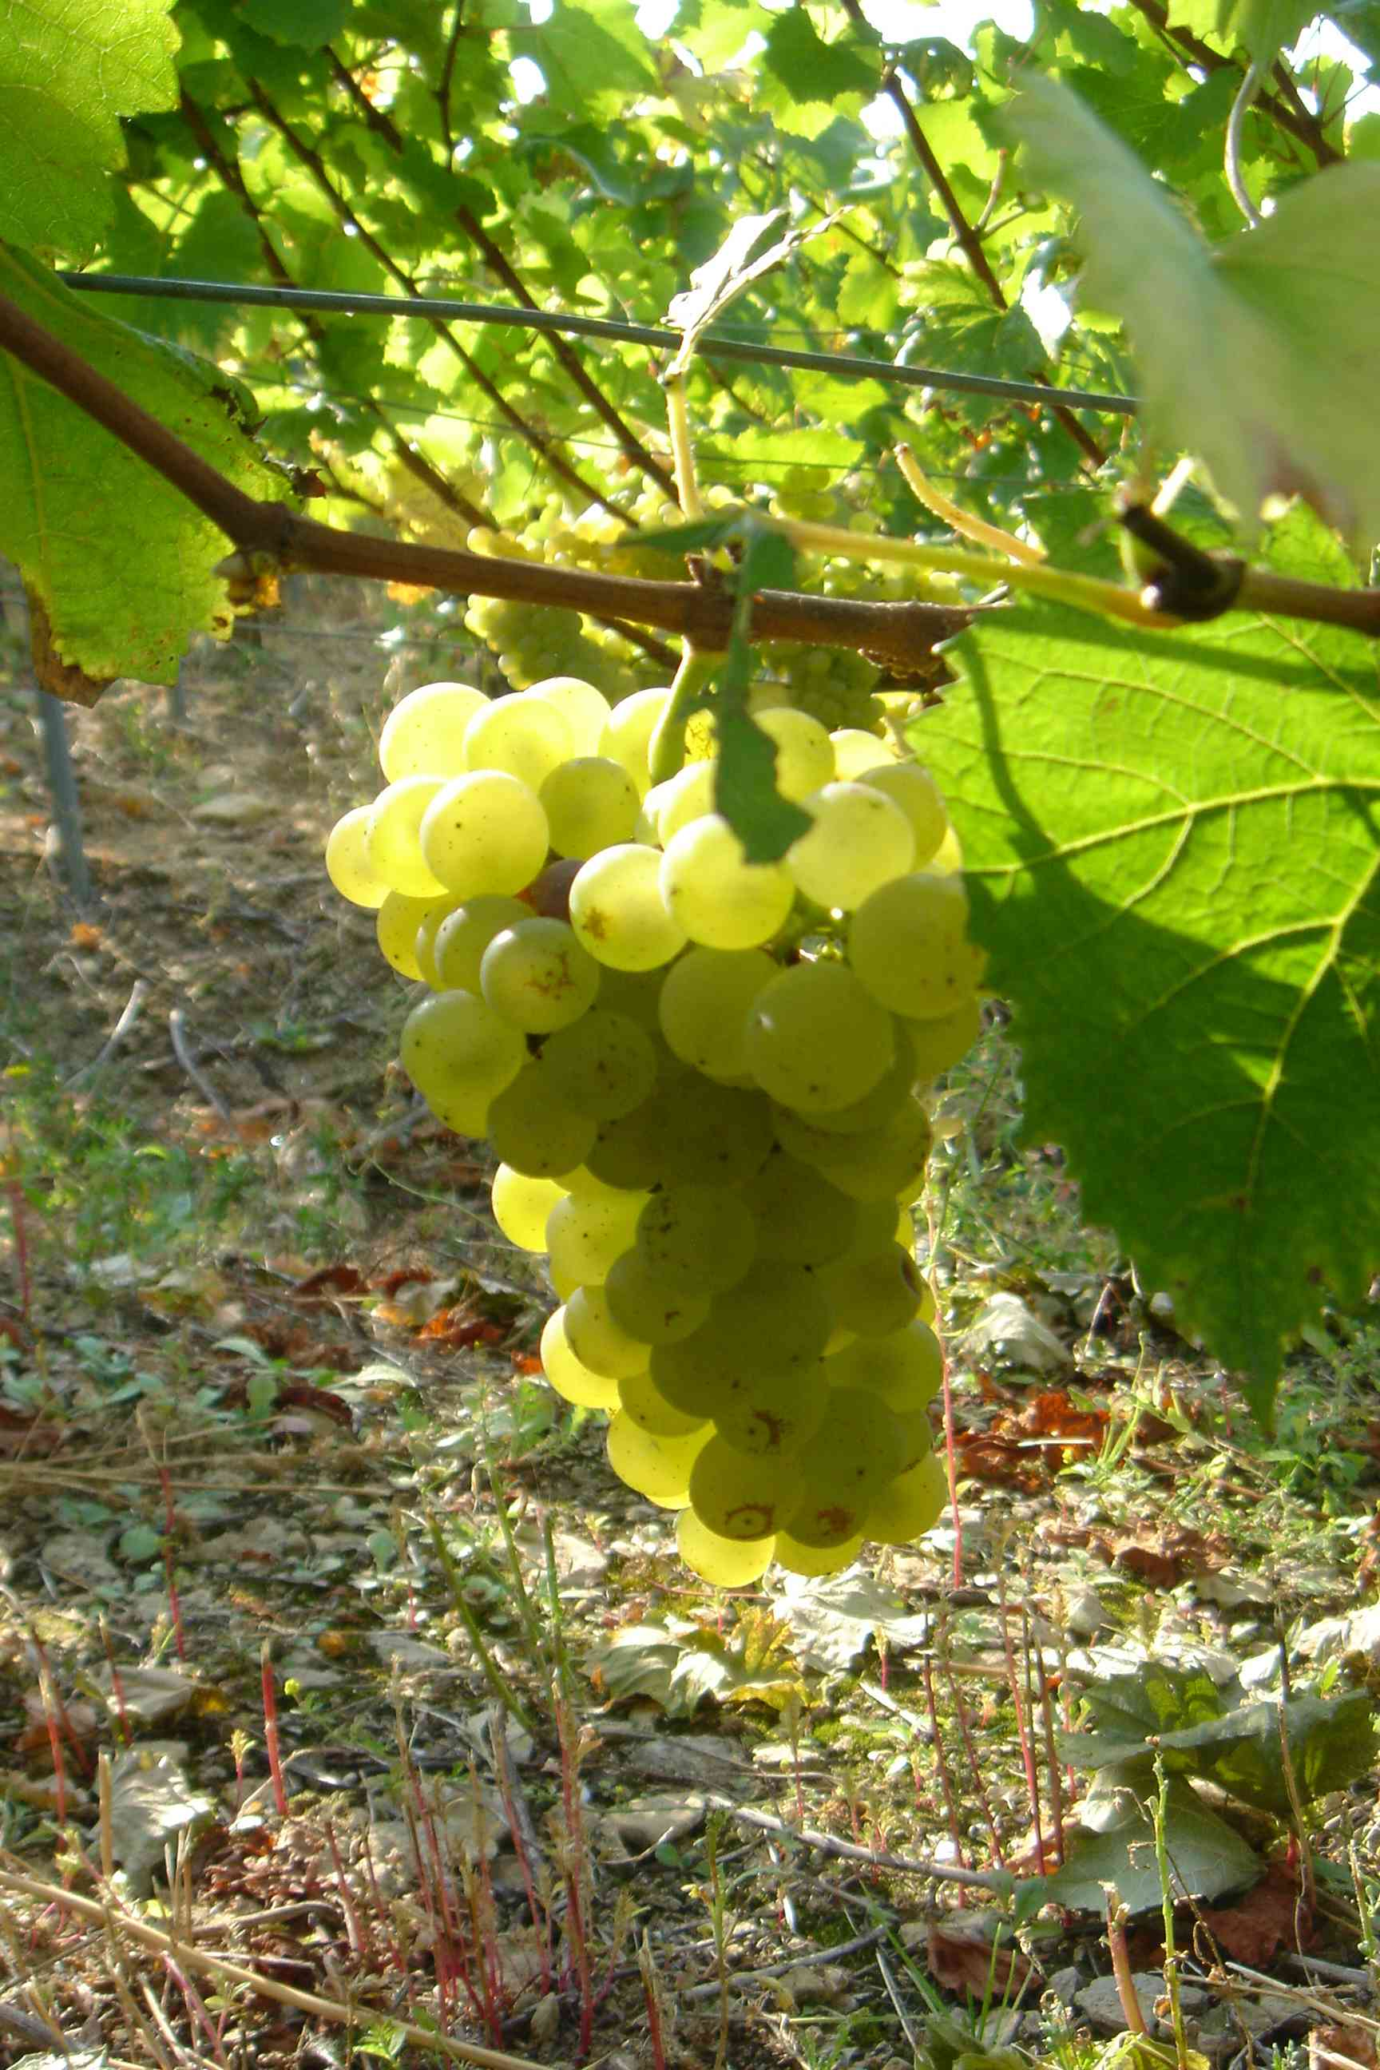
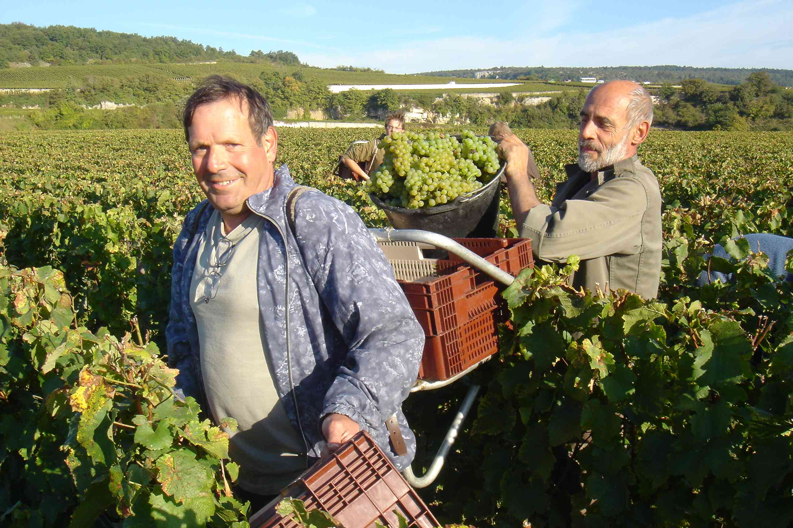

On the Côte de Nuits, the team did their daily vendange of the Clos Blanc, in the vieille vigne section at the top of the plot where they found some divine golden grapes. Then they went on to harvest the plot of Clos Vougeot located in the lower part of the Clos and known as “Ponnelle”, in reference to the origins of this vine which became part of the estate in 1987. Formerly vinified separately, the careful work carried out in the vines now means it can join the other cuvée of this grand cru, and hold its head up high, as the little sorting required clearly demonstrated.

Then they harvested a further 120kg of our very dear – and you can understand why – star wine, the Musigny. The bunches were once again very patiently and lengthily destalked until nightfall by successive teams of volunteers amused to discover Thomas’ magic tricks as he made water disappear before their very eyes! Apparently, he also knows how to turn water into wine, but that’s another story...

The pressure has risen a notch in the winery, and we’ve discovered a new side to Pierre... Amazed that the crémant that came in at the end of August still isn’t fermenting, he put two containers of it outside to check, and fermentation began immediately. Confused, he thought long and hard about why this wasn’t the case in the vat, and then overtaken by hard work, he forgot about it a while. A few days later, Amandine discovered he’d left the vat’s thermostat set at 12°! An involuntary, fortnight-long cold stabulation may perhaps set a new trend – who knows? – great discoveries are often born from chance. Keeping the must cold isn’t a big problem – quite the contrary – but it is rarely done for so long. Now, fermentation has begun, and it’s certainly a celebration for Pierre as it will be for us in three years’ time when we taste this sparkling and memorable Fête de Famille…
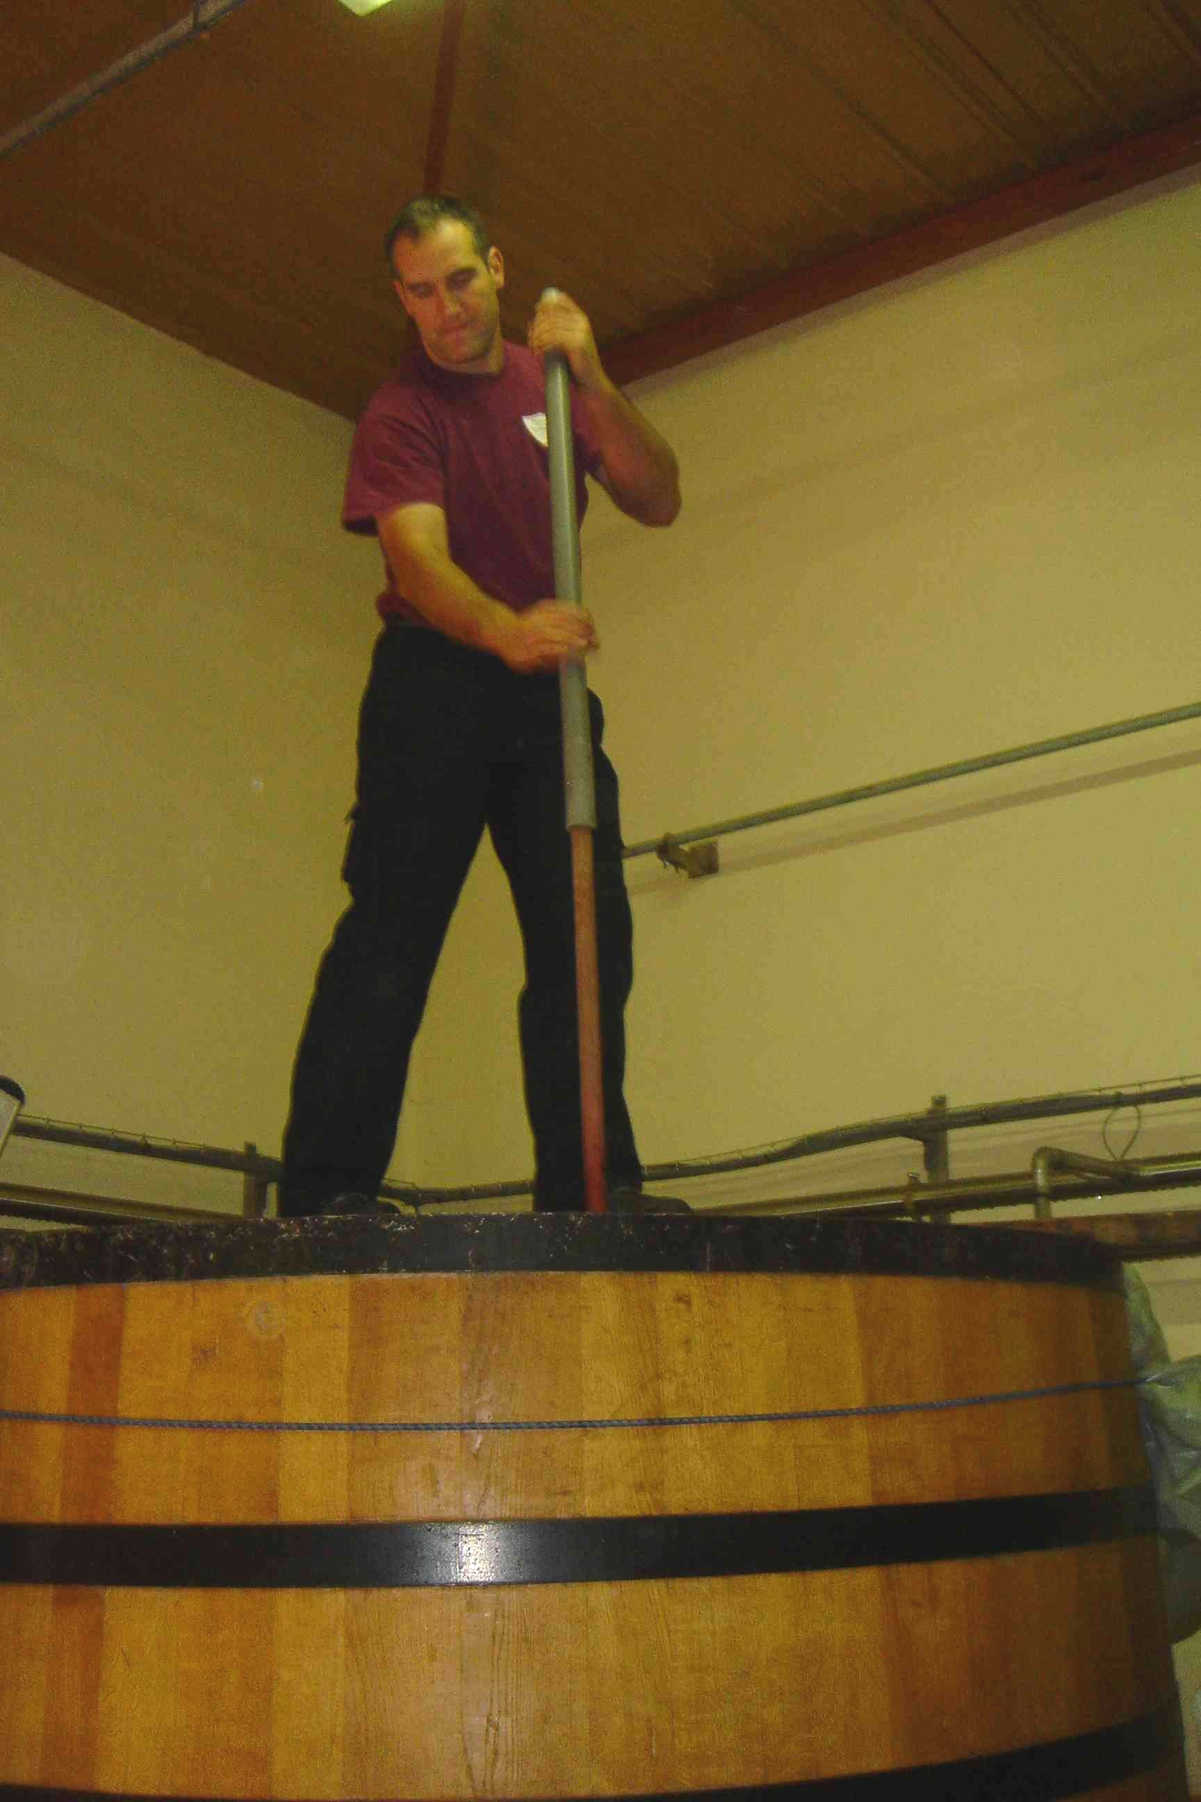

The task is indeed becoming more complex, starting with the red fermentations which are rapidly coming on line. Les Marconnets went from 18° to 31° in three days, in a speed the like of which we’ve never seen before. The perfectly sorted grapes are healthy and thus rich in nutriments, trace elements and yeasts, containing nothing to hold back their development. This speed is perhaps indicative of an overall trend, as the Clos du Roi seems to be progressing in a similar manner, when last year, we struggled to reach 28°. The days’ four pressings – of two-and-a-half hours each and an hour in between for cleaning – took us through to 1.30am. Tomorrow is Saturday and the day of the Paulée, the traditional Burgundian celebration of harvest’s end, but it probably won’t be the last day of our vendange...

