Tuesday 11 September 2007
Day nine

Patience and time…
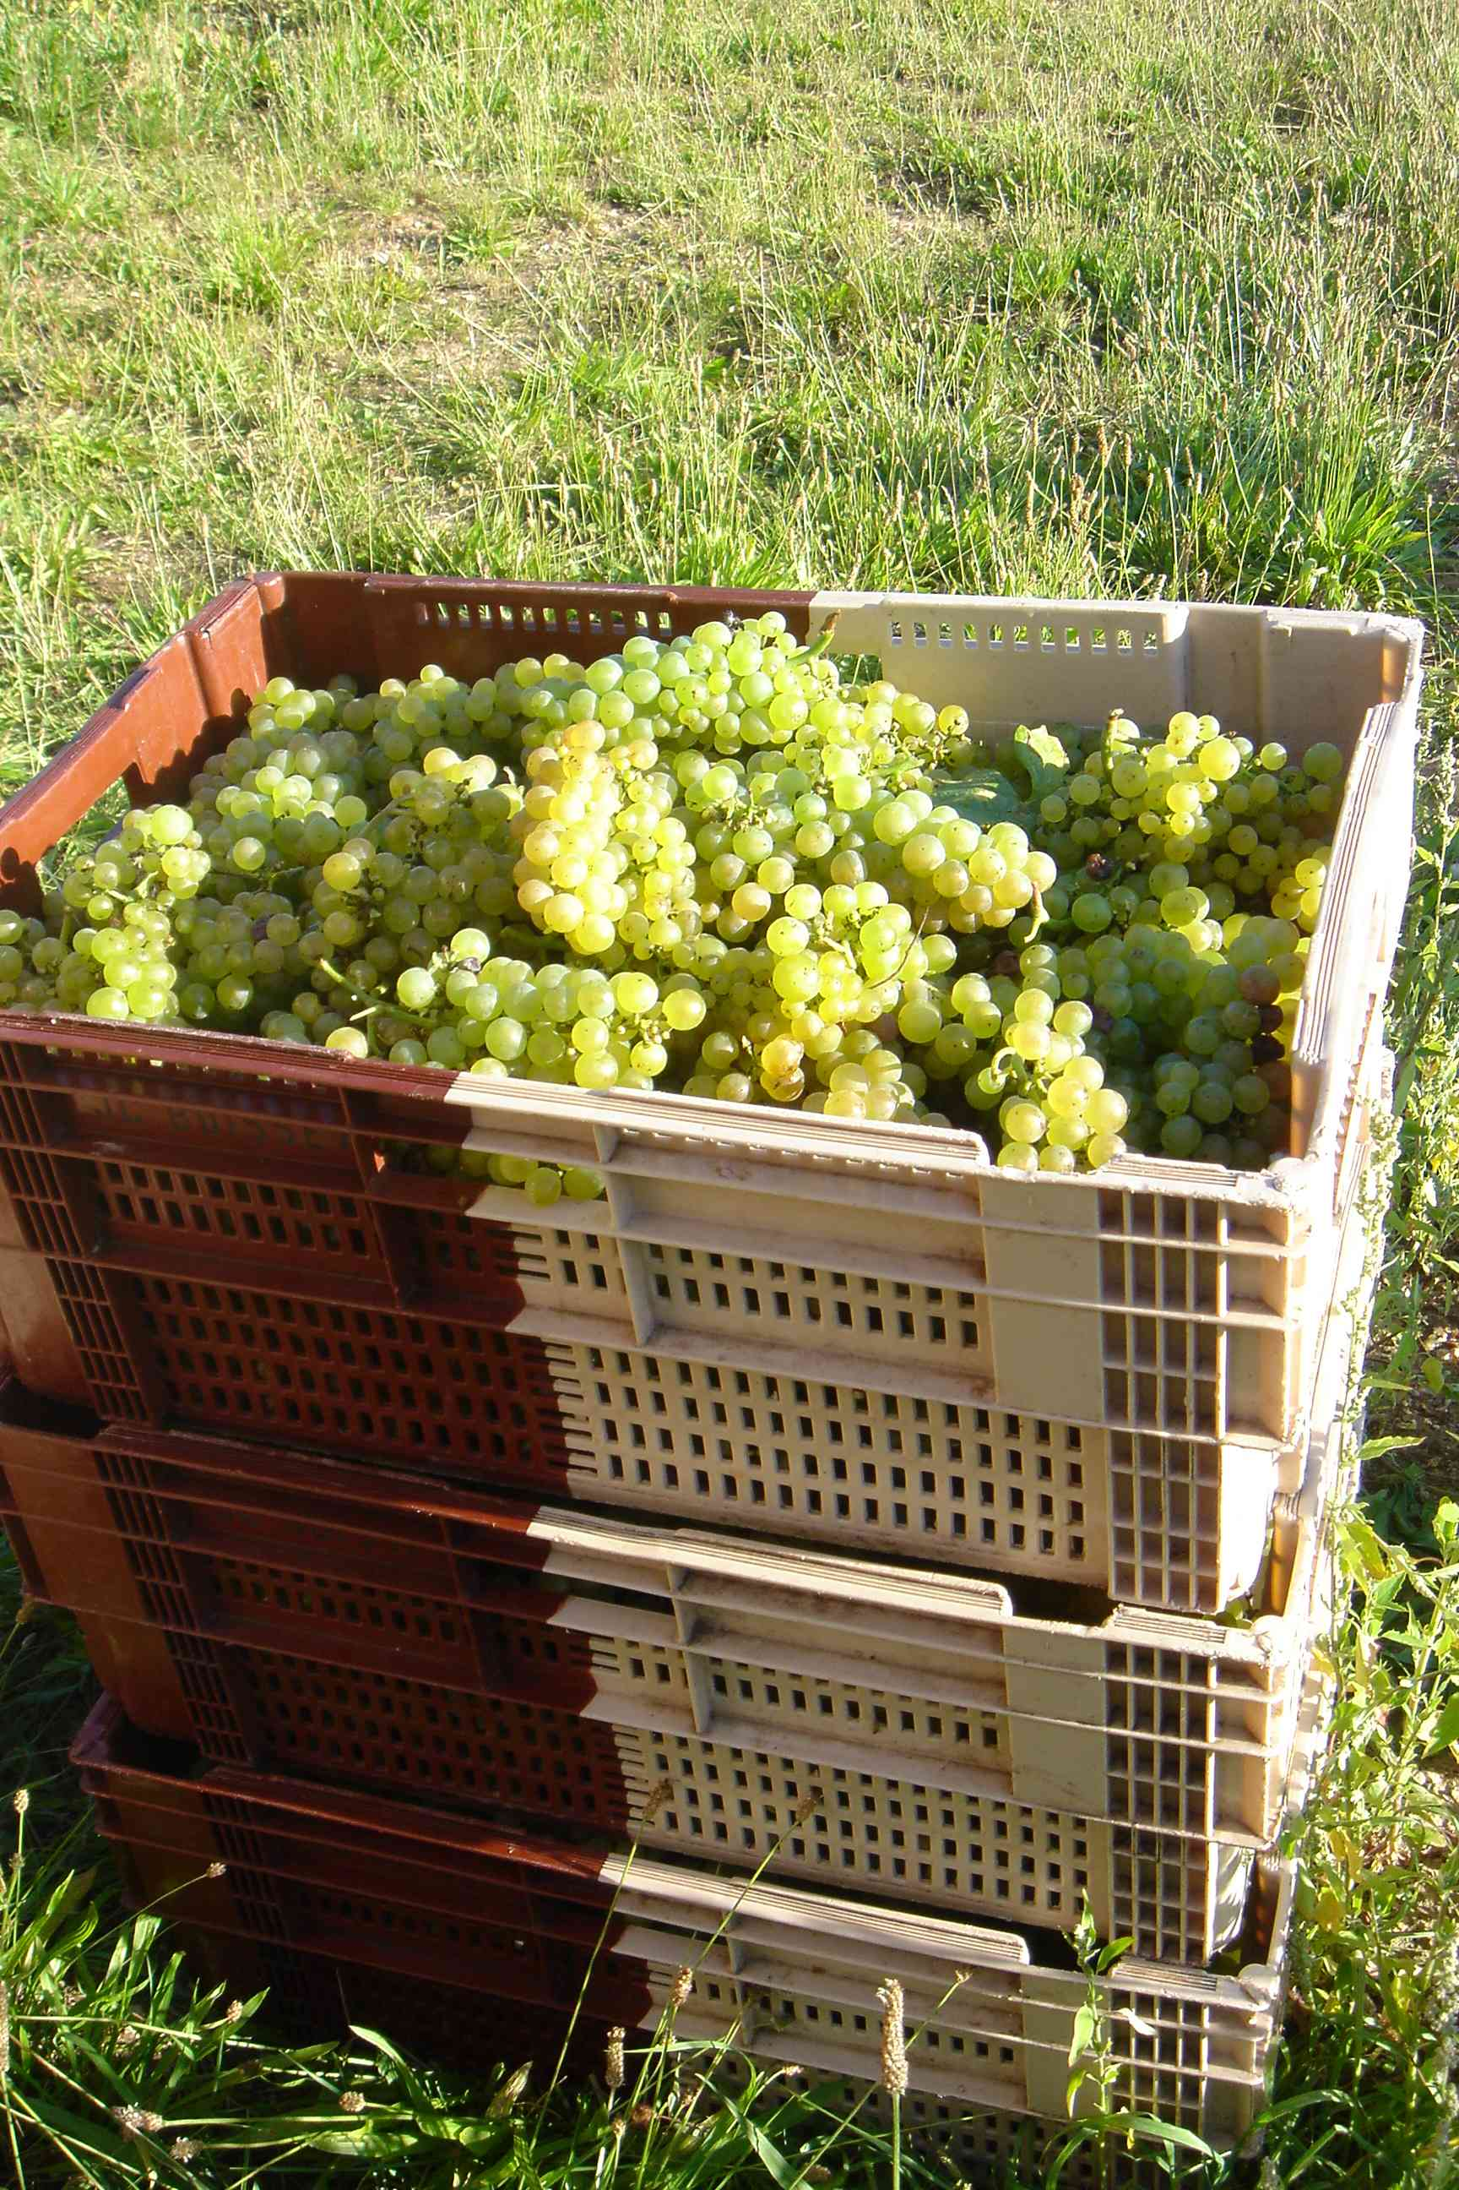
The weather may be cold and gray but spirits were high this morning among the pickers and the team in the winery. This was especially good news, given the amount of work on the cards.

To provide a break from the monochrome harvests of the past few days, today was mainly dedicated to harvesting the whites from the Côtes de Beaune, in the small plot of premier cru that has been referred to by winemakers since time immemorial as “La Vierge Blanche” (The White Virgin), part of our Beaune La Montée Rouge. Perhaps they were asking for favors from the protector of the city of Beaune - who knows? But in any case, our patience has paid off and the levels of maturity were very good, with a natural potential alcohol level of some 11.7°. The grapes were lightly sorted and around 15% of unripe ones were removed before the press came into action. The Beaune Blanc harvest offered two presses-worth, making 12 pièces or 3,600 bottles. And patience is what they needed throughout the day given that a pressing lasts two-and-a-half hours. So there was no respite in the winery and the team had to keep up the pace in order to finish on the early side (at a relatively respectable 9.30pm).

And because there were a few vines of red left to harvest, the Beaune team’s day finished with Les Pierres Blanches, where the grapes – a little less fine than on the Côte de Nuits – reminded us of the 2006 harvest.
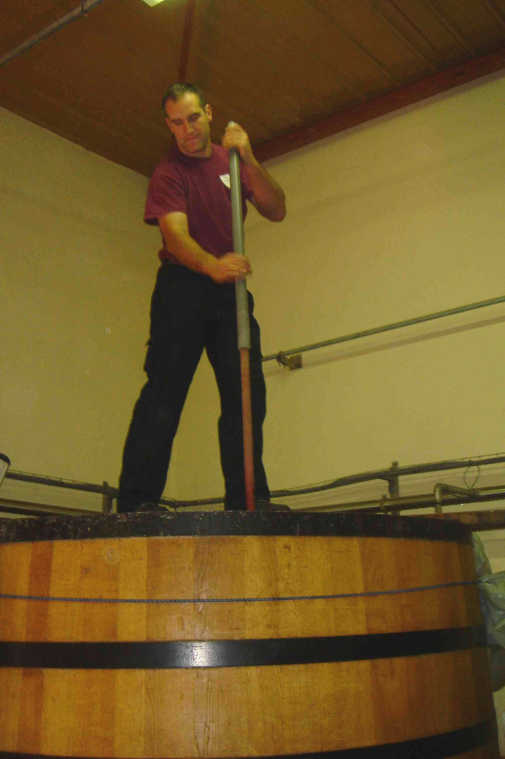
Meanwhile, early on this morning, the pickers on the Côte de Nuits finished the Premier Cru Les Damodes in Nuits-Saint-Georges, with its wonderful grapes, some of which were figués with a high sugar and low water content. This is exactly what is needed to produce a wine that simply speaks “fruit”.

And then they headed towards Gevrey-Chambertin, for a plot very close to our hearts: Les Evocelles, at the top of the Côte looking over the grand crus and right next to Fixin. These were the first vines of the Domaine that our grandfather and father planted in 1966 after laboriously clearing the land. The name “Les Evocelles” comes from an old French name “Les Brosselles” which refers to the fast-growing brushwood. The grapes were fine and only a light sorting of no more than 15% was necessary – the price of quality!

And back to the winery, where fifteen busy bees were bustling around the sorting table, the vats and the press today. Twenty-eight vats out of thirty are now filled and we have reached cruising speed. After having left our red grapes to rest in their beautiful wooden vats, it is now time to gently wake them up with a daily pigeage to break up and turn over the cap of skins and pips.

As for the whites, Jean de La Fontaine was right when he said: “patience and time do more than strength or passion”. At the Domaine this year, we’ve made this our motto, needing patience to wait for the perfect moment to harvest the chardonnays at the peak of ripeness, and to vinify these precious berries. Indeed, Pierre has programmed the press for a longer juice drainage time to extract the very quintessence of the grapes.

Despite intense activity with the incessant comings and goings, the winery during the harvests is incredibly clean and woe betide whoever transgresses the rules – Pierre is there to remind them. So to avoid the thundering cry of “slippers!”, Christophe slips his on before entering.

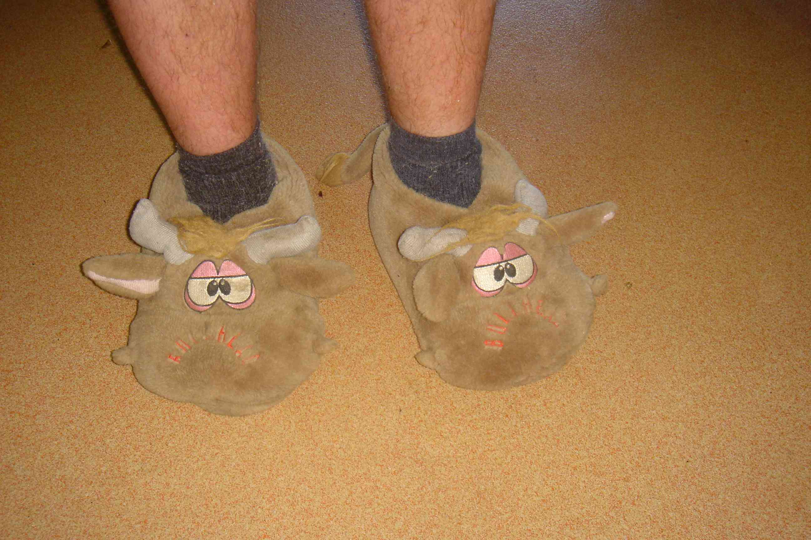

Don’t forget it, dear reader, should you ever be a visitor to the winery yourself...

