Monday 3 September 2007
The first day of the harvest

First grapes and first impressions...

As the local children trotted dutifully back to school, our pickers took their places in the rows of the Domaine on this “root day” in the lunar calendar, ideal for encouraging the grapes to best express the terroir. Some new faces figured among the team, mainly from the four corners of France, but also from Portugal and even Congo, joining the small group of habitués who patiently chaperone the newcomers every year. Sadly, some familiar old faces from far away lands like New Zealand and Australia were unable to arrange the necessary paperwork in time to be able to come and help us this year. It’s a pity, and we’ll miss that cosmopolitan atmosphere.
After a weekend which eventually turned out sunny and relatively hot, giving a slight increase in the grapes’ maturity, the weather was cool and cloudy this morning. In the vines, the dew was a wake-up call for the pickers, hard at work from 8am.

We are now embarking on the Domaine de la Vougeraie’s ninth vintage and as in previous years, the pickers are divided into two teams; one for the Côte de Beaune and another for the Côte de Nuits. Unusually, however, we didn’t start with Le Clos Blanc. Each year is different, and this year, the chardonnay – a vine that loves its sun – is less mature than the pinot noir. The samples Pierre has taken in the vines confirmed his decision.

On the Côte de Beaune, the harvest began with our Savigny-lès-Beaune Premier Cru Les Marconnets vines, as planned. Twenty four pickers and five haulers took on the two hectares of vine, but they won’t finish it all today.

This vine is unusual in that it is made up from two plots. One higher plot gives riper grapes with more millerandage or “hens and chickens”, looser-packed berries with varied sizes, which offers a real measure of concentration and gustative quality. The lower plot is more tucked into the valley, and this year, given the wide variations in the grapes’ maturity, Pierre has decided to vinify the two plots separately.

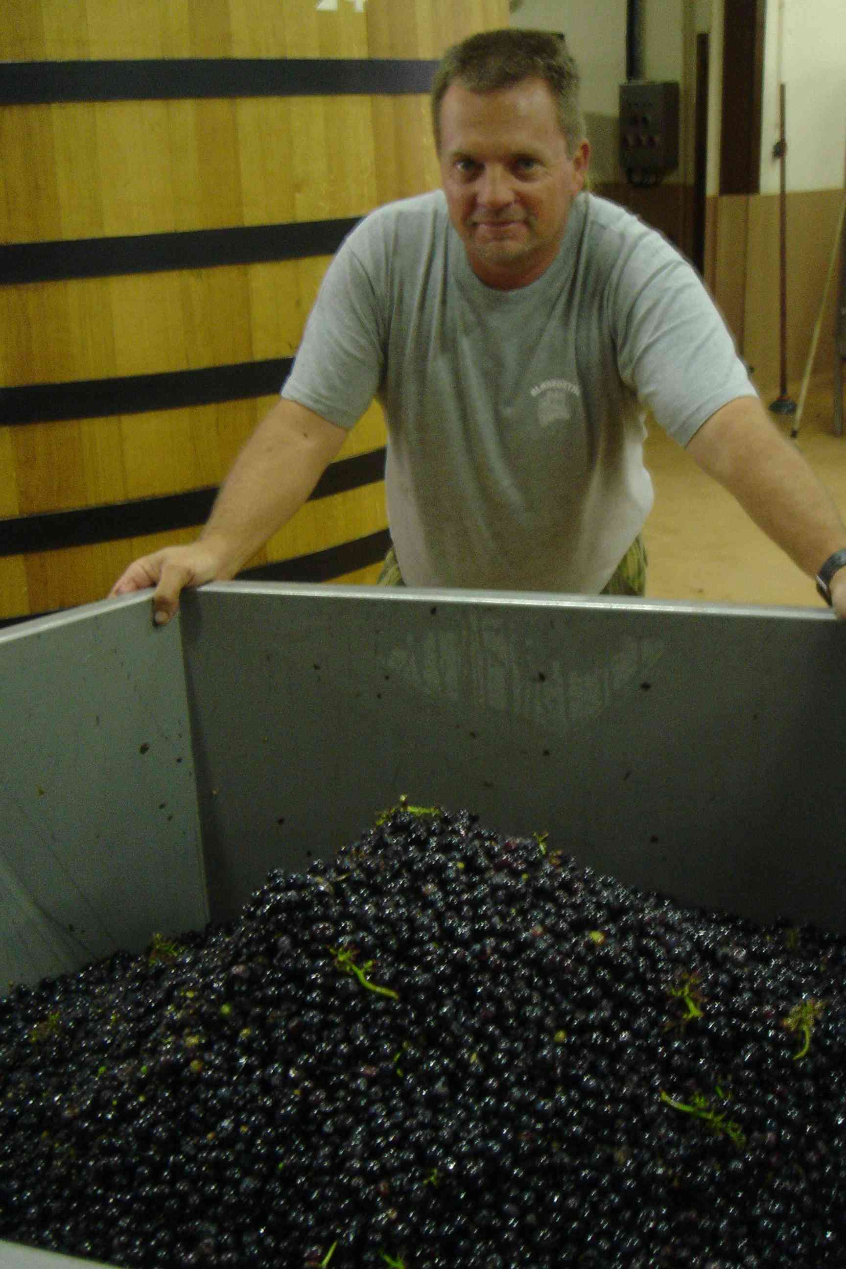
In the winery, work is intensifying. The grapes are subject to a very strict sorting process, with Pierre standing at the end of the conveyor belt to check the selection has been rigorous enough: 20-25% of grapes were rejected, and only the very ripest and healthiest ones made it into the winery. With this first batch, there was quite a lot of rot which was swiftly eliminated by the eight sorters without hesitation – absolutely perfect raw materials are the price of quality.

This is clearly demonstrated in the “destalked” container that Frédéric is taking to the vats which stand ready to receive the nectar from our vines.

Meanwhile, over on the Côte de Nuits, 38 pickers were hard at work in the vines called En Bollery, situated opposite the Clos de Vougeot. The grapes were in fine condition and only 10% were rejected.
Here’s hoping it will be the same story tomorrow – there are still 1.5 hectares left to harvest.

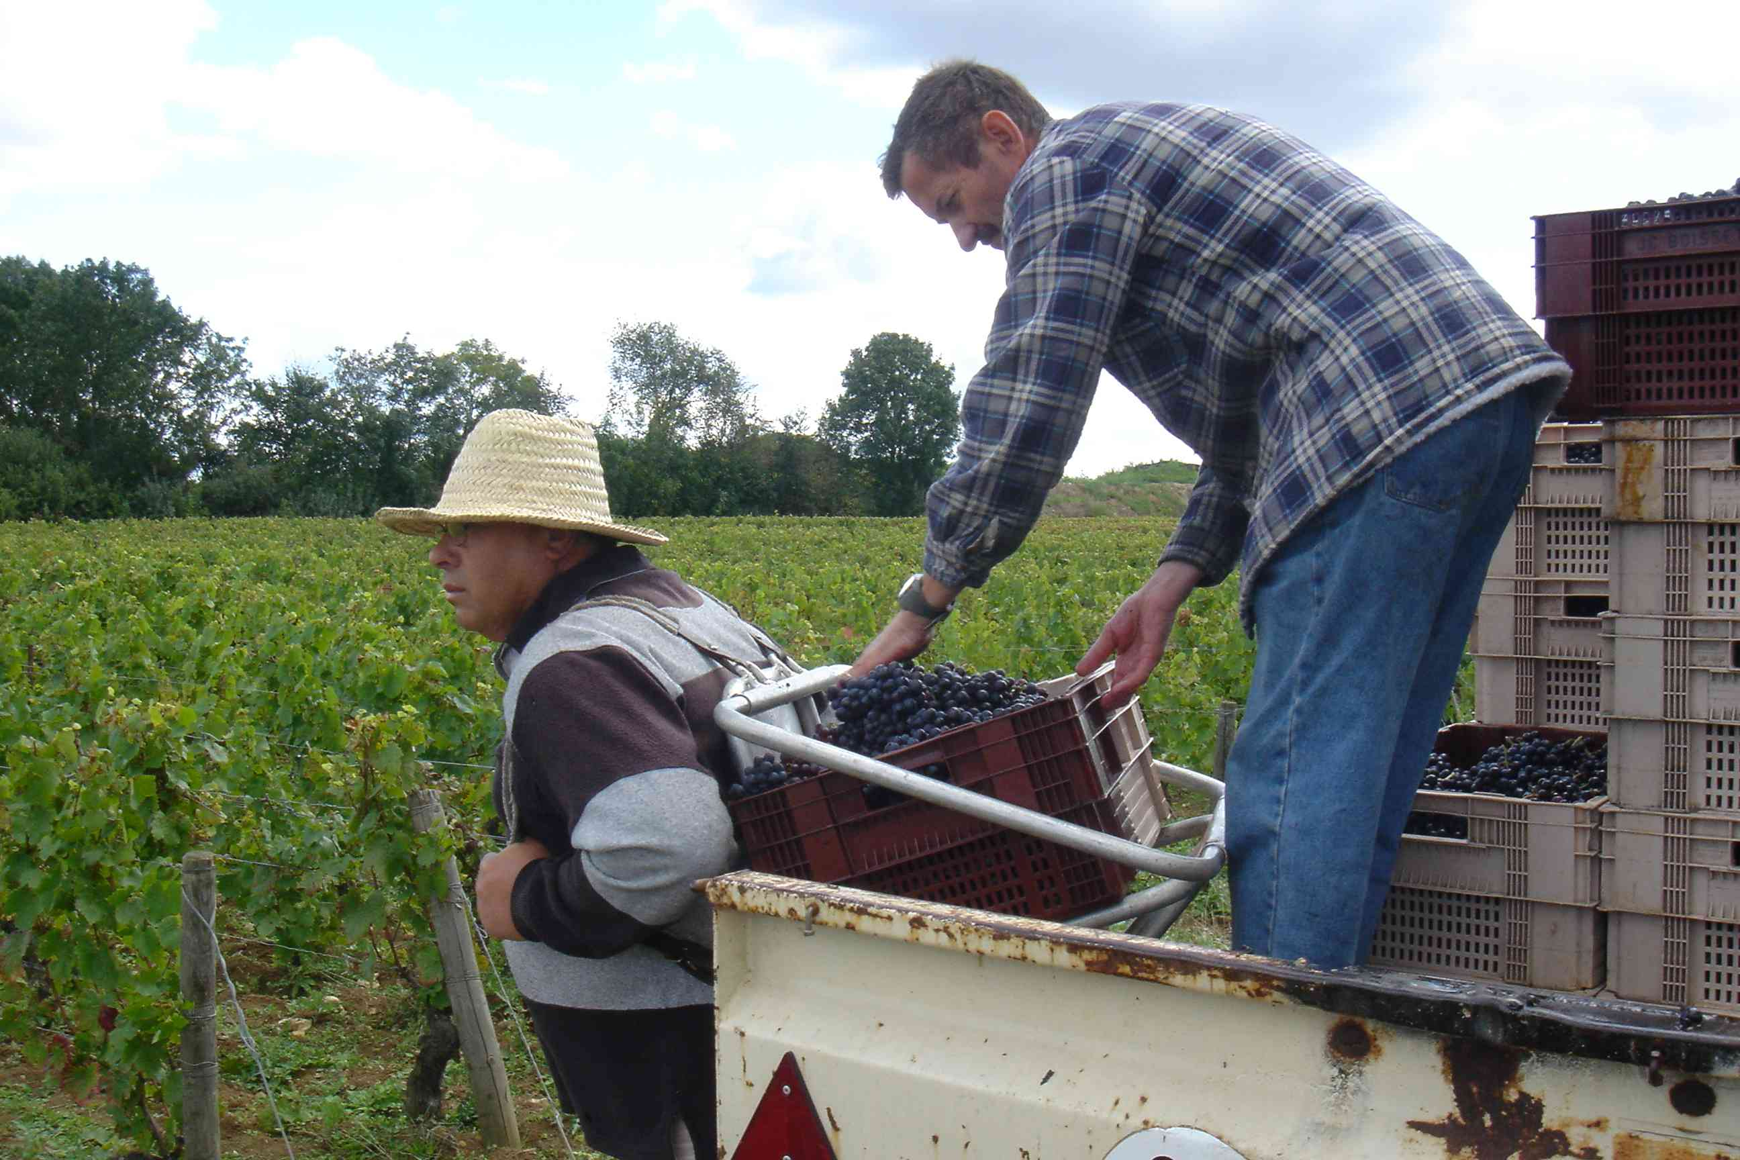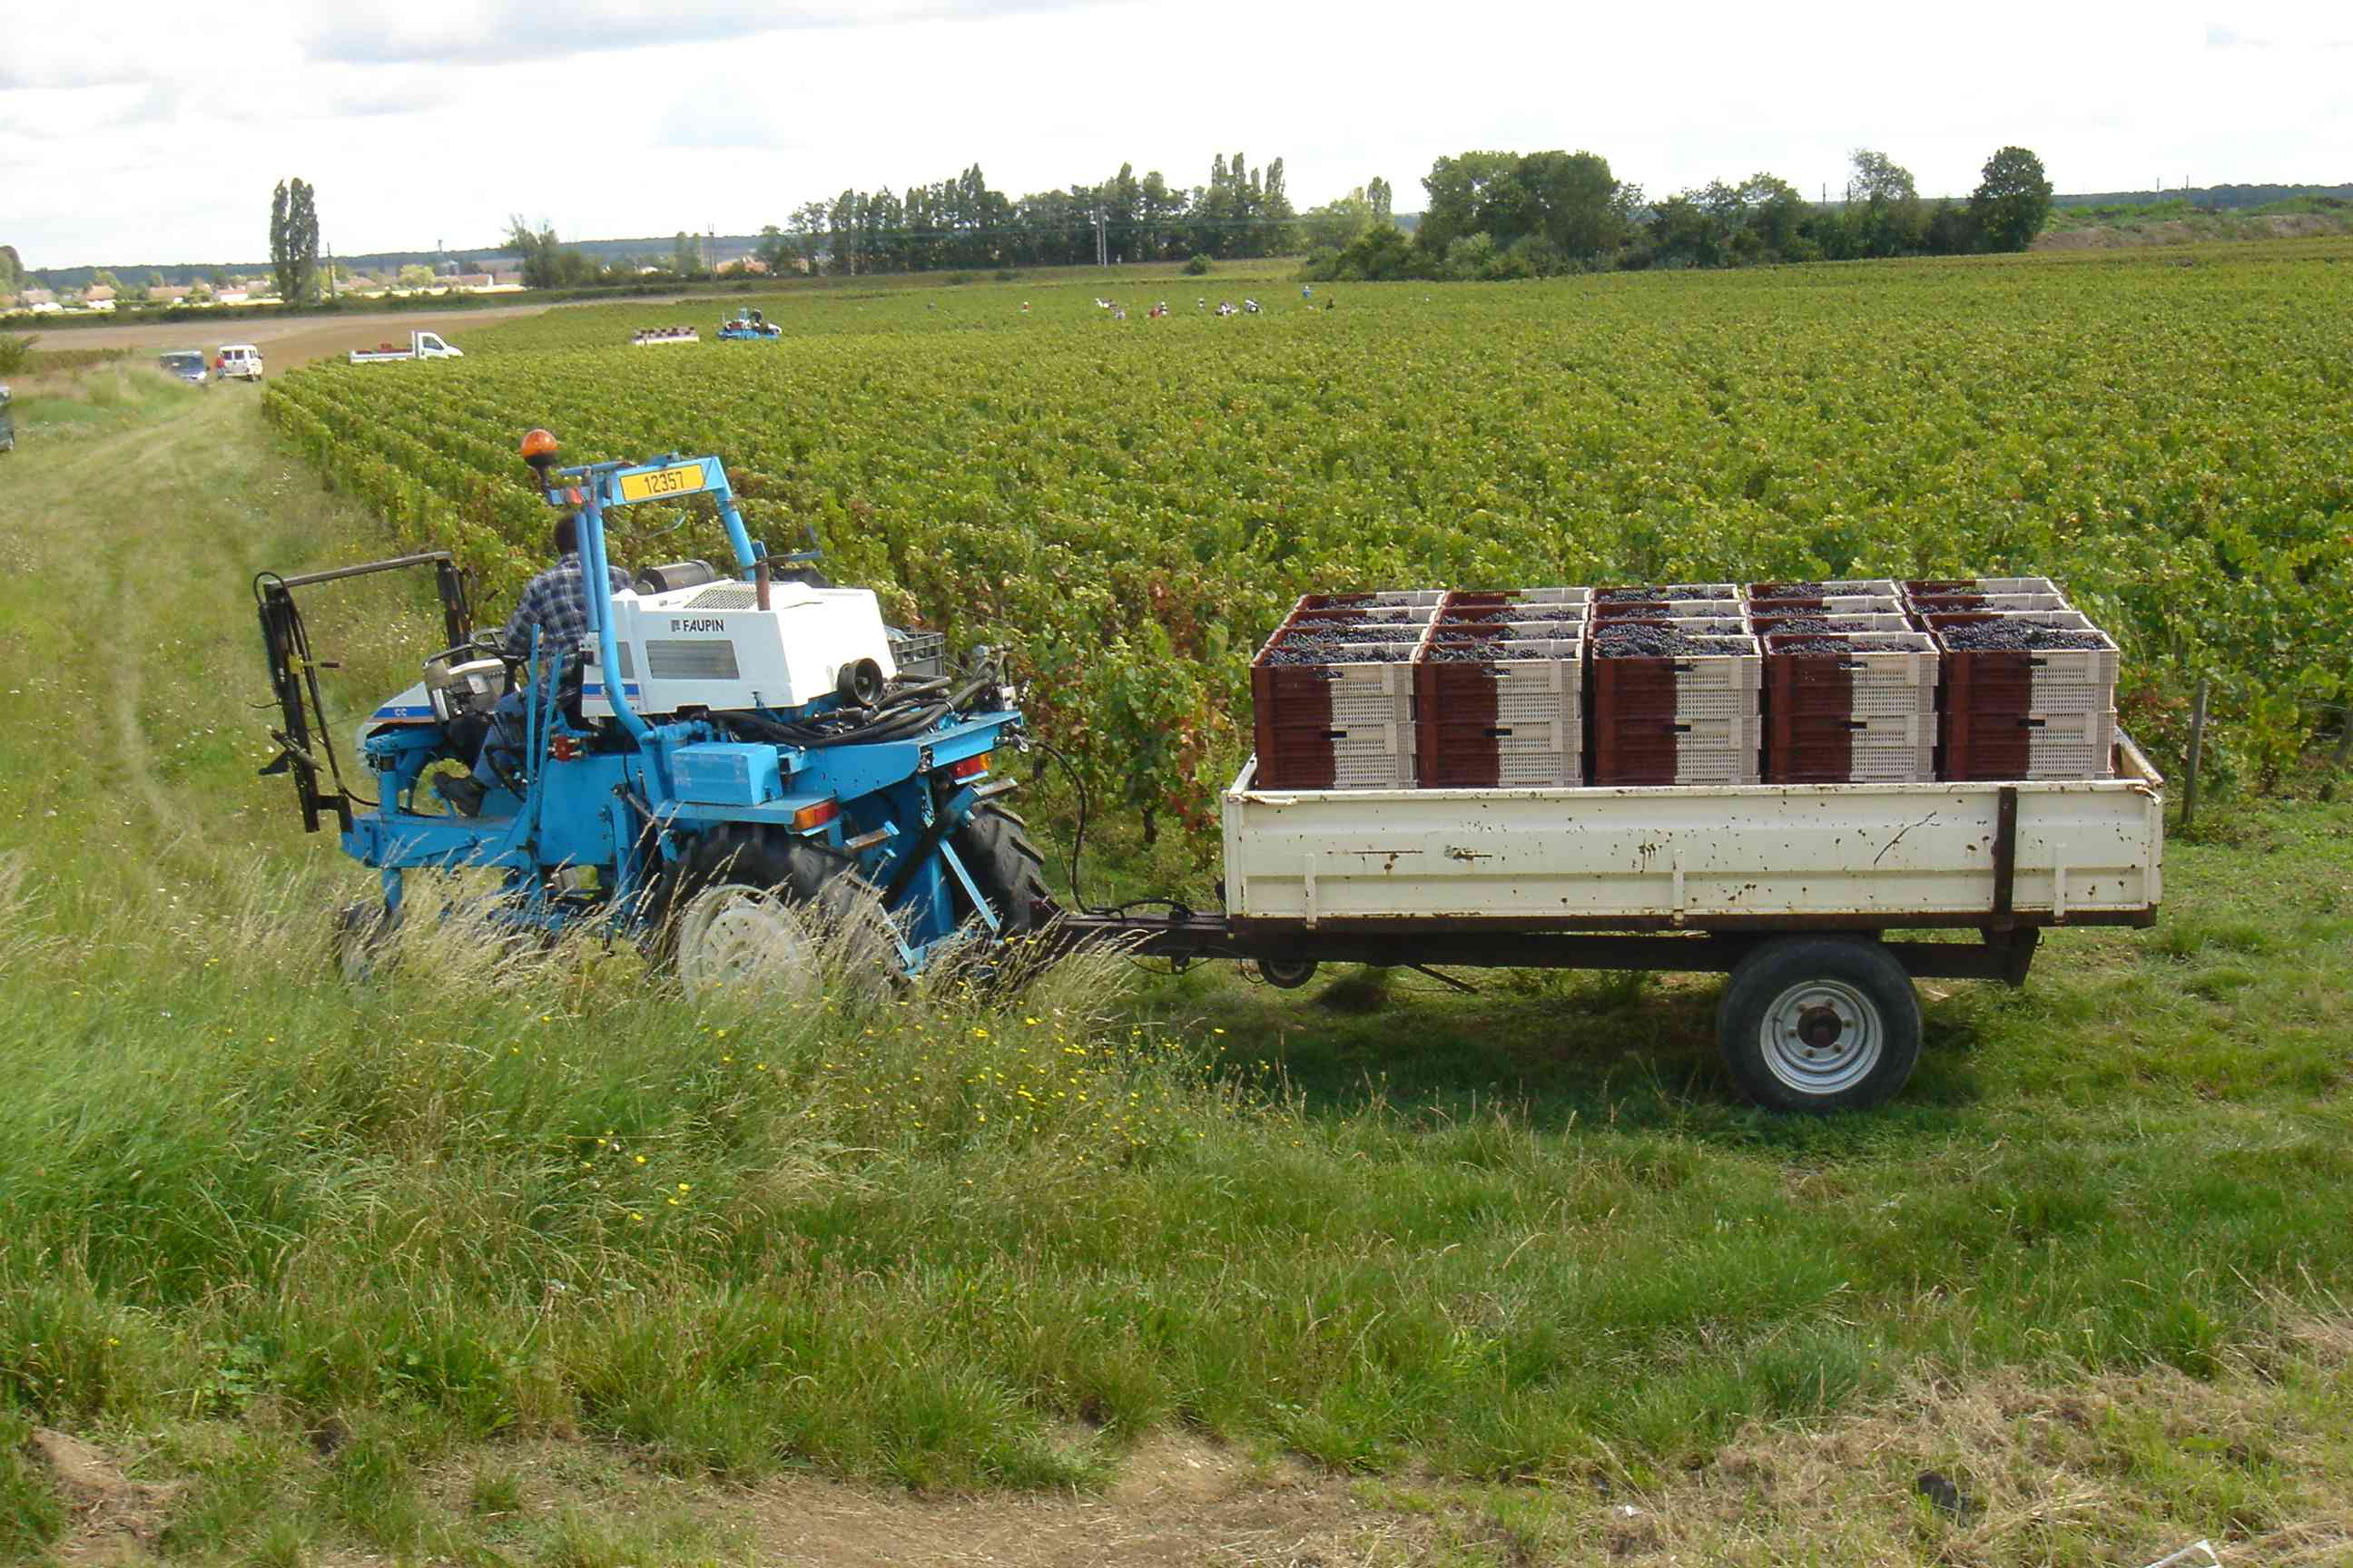
Terres d’en face En Bollery

It looks as if the 2007 vintage will be very mixed, making the sorting process and the work in the vinery even more crucial for the quality of the future wines.

At 11pm, the winery is finally quiet after an intense and very long day for the small team of sorters. Fortunately, some more help will arrive tomorrow, to help keep the pace up to the end.
The first grapes are now peacefully settled in their vats, undergoing the first stage of cold pre-fermentation, to avoid rushing the future wine and allow slow and natural color extraction.

